**Steps for Managers to review and process an application on Site manager, PRIOR to sending to Right Source or compliance manager for the review to get a final approval:**

* AFTER completing both the Waiting list application (it should be green- submitted status) and you have opened the Move in application for them to complete – once they pay the fees, the screening report will be auto-ran.
* Once MI app is completed and applicant and came back with accepted screening report OR once I email you and let you know they can continue their application *(If Some screening reports may automatically come back as accepted right away, some come back as pending or condition or denied and need further reviewing to confirm if it was approved)*
* Once screening report is confirmed as accepted, and they have fully completed their application, meaning all of the docs are signed and have been submitted by the applicant.

(A completed application that was submitted and signed will be blue and show as in pending status)

* At that point is when manager verifies that all documents are uploaded (as listed based on the household listed on the “before submitting any applications” – see below how to review and verify all application documents.

**How to complete the Household verifications in Site Manager**

1. In site Manager 🡪 from top orange tool bar 🡪 Click Compliance tab🡪 then from the Compliance Management dashboard click “**Search all”** button 🡪 then select the property and search the name of the applicant.



1. **Find the applicant you want to verify-** be sure that there is a green submitted WL app AND a submitted Move in application that will be in BLUE pending status. **– then click the BLUE move in application to review details.**
2. Once you click that applicant’s name, it will open their household page,
3. Managers will now need to review and verify each tab to properly complete each of the required verifications to submit an application to Rightsource (shouldn’t be any error messages when you click “submit to Rightssource”)
4. To start verifications, from the Applicants household page 🡪 You first will need to go to the documents tab to make sure all ID/SS card verification documents have been uploaded



1. 🡪 Then on the members tab 🡪 Next to each household member -> click **edit** 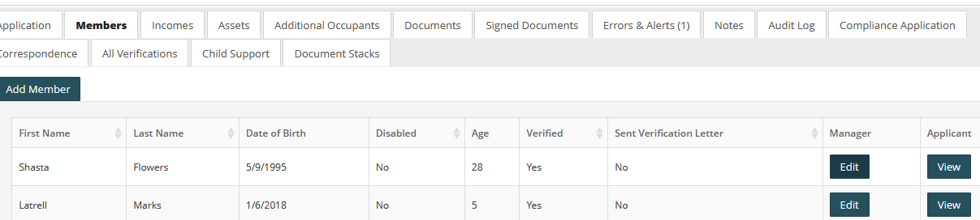



After clicking edit 🡪 for each household member you will review the **tax credit data tab** for each person🡪 Choose the relationship to household type and employment type (shown below)

just leave the last one blank (PSR Special status) not sure what that is🡪 then click save

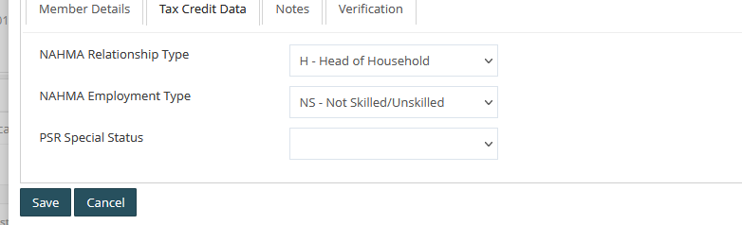



Then click on Verification tab 🡪 click edit 🡪 then add in the verification (usually 3rd party docs) – to verify that each applicant has uploaded the correct household identification documents



🡪 Continued

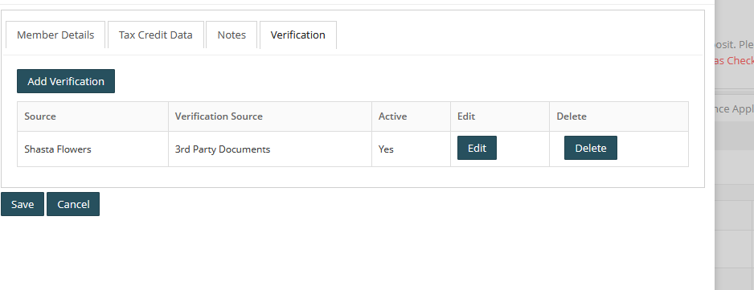



After entering new verification for each you will see it show up as shown above, under “active” it will say **YES** if you select the box “**Use this verification**” it will say No if you did not check the box

**– All necessary verifications need that box checked to be able to submit the application to right source.**

*(See instructions below showing where to find that box)*

🡪 **make sure you select the box “Use this verification source” so that it will be shown as verification completed for this source of income.**



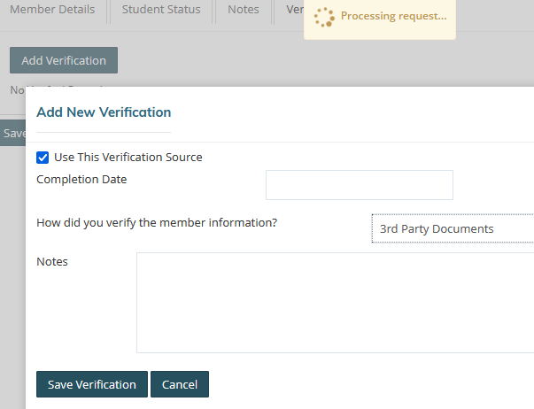

1. Go to the documents tab and find the income documents that they have uploaded



1. Then click on the on the **Income** tab



1. Then comparing the uploaded income verification documents 🡪 click on **Edit** button next to each income source to verify each of them



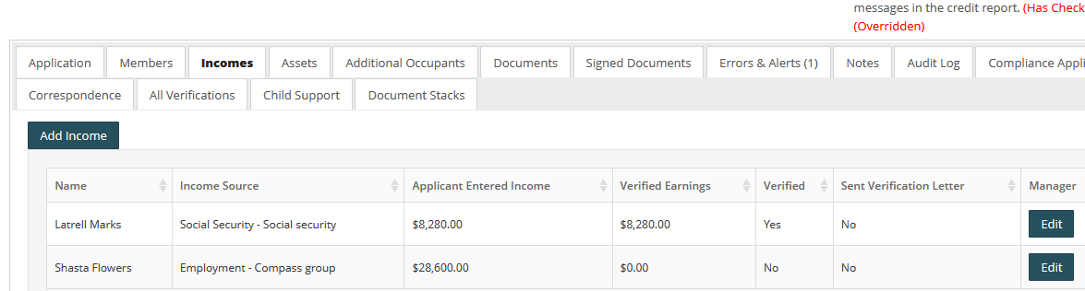



Once you click **edit** button🡪 You can review the income details that the applicant has entered themselves the verification tab you will click “add verification” 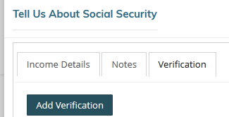



1. Once you click “add verifciation” button 🡪 you will be able to verify the income --. Choose the way you would like to certify the income from the drop down box documents (check stubs, YTD, pay rate, etc)

And also select the appropriate Type if income and you can also add notes as necessary

1. Then add your income verifications 🡪 **make sure you select the box “Use this verification source” so that it will be shown as verification completed for this source of income.**

**(You can click Add verification again to create multiple income types of verification types (stubs, YTD) – you should have 3 separate calculations if possible to choose the highest.) – then just be sure to select the “use this verification” on the verification you want to be submitted to voyager. (eave the others unchecked)**

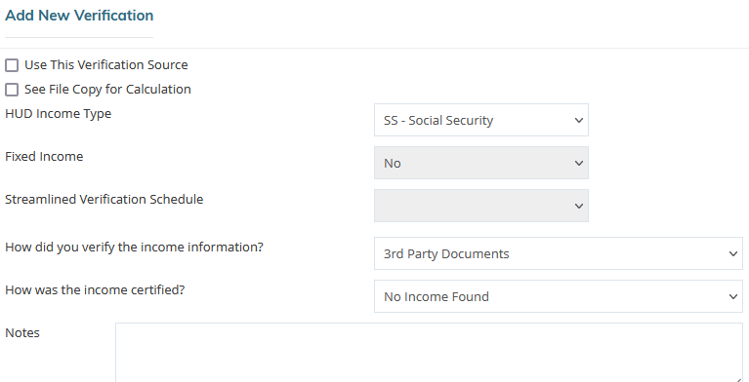



1. Then repeat and do the same thing with any other income sources and then repeat steps for assets tab
2. If you missed any other verifications 🡪 the error tab will show a number (how many errors the app has or how many missing verifications that need to be completed prior to submitting to right source.

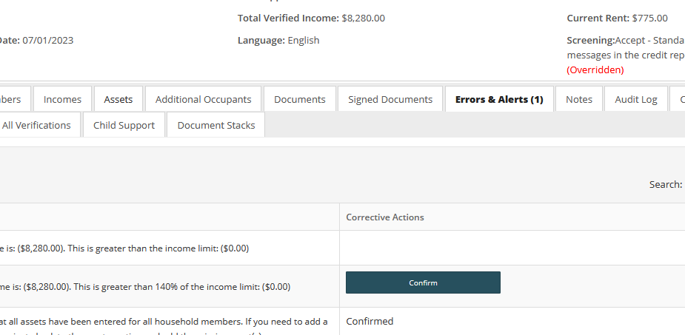



1. Screenshot below shows if you properly verified income, assets or household members, by each item under “verified” it will say YES, if it still needs to be verified it will say NO

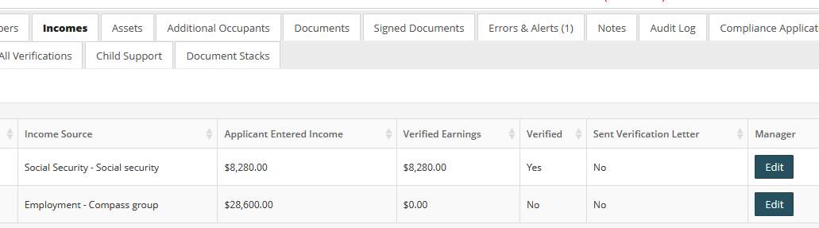



Verify that all of the necessary required household verification documents have been uploaded and verified as the instructions and screenshots shown above.

* Verified all adult household members uploaded their ID, SS card and Birth certificate
* Verified all minor household members uploaded EITHER their SS card OR Birth certificate
* Verified all sources of income listed
* Verified all sources of assets and expenses listed (if added on their application)

🡪 Then finally, once all of those items are verified, the manager will be required to countersign the documents prior to submitting to rightsource for final approval. (See screenshot below how to do this)

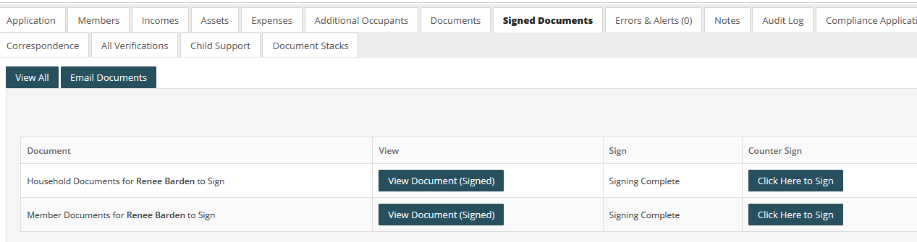

If after completed the listed verification items listed above, you get an error message when you click the “Submit to Rightsource” button, that means that either:

* You missed one of the necessary verification steps or didn’t check the Use source button (as mentioned above) for one or more of the necessary verifications. – (see above screenshots)
* And/OR you may need to just click on the error tab to review what errors its shows need to be cleared, -- if you see any blue buttons to confirm any errors it may be showing
* If those items showing as error were already clarified or is not actually an error then click on the blue Confirmed button for each. An error will show up is when manager has not yet countersigned the documents- **make sure to always first countersign the documents before clicking the confirm button for that error**, otherwise the error will still show and the docs won’t be signed (see below)

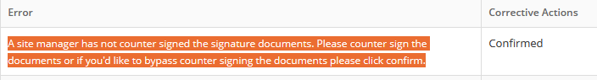

* And/OR You can also get an error that will show a confirmed button showing as the applicant is being over income – even if you click the confirmed button, it will still not allow you to submit to rightsource with that error – so read all errors carefully.
  + If over income then app is denied (as the screen shot on above page shows)
  + If the over income amount listed is incorrect, then go back to the income tab and correct the amount you verified as your income calculations, if need be, then go back and the error should then disappear