**HOW TO OPEN A NEW CERT FROM SITE MANAGER IF TENANTS DO NOT SEE THE CERT IN THEIR APP PORTAL:**

1. **You will click “Create application” button (top right-hand corner of the household search page (site manager)**

****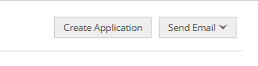

1. **Then the dialog box will come up asking for details for the cert you want to create (you have to pull up and enter the tenant’s details (found in yardi) Soc Sec #, DOB, email, T-code, etc) then click save**

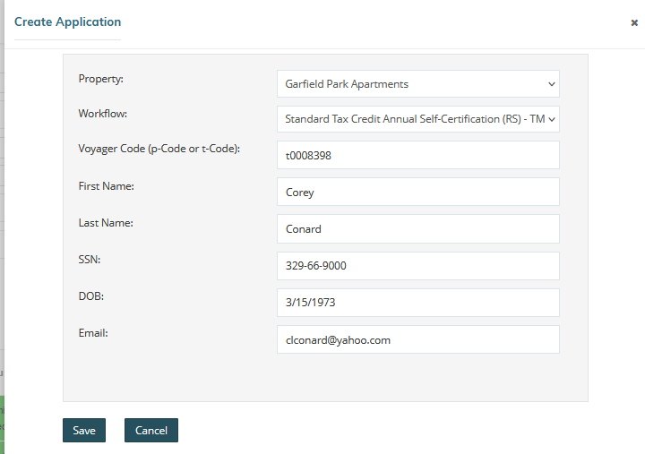



1. **Then the certification household page for the cert you created will open up in your window:**
2. **Once you get to this step you need to make sure to go to the “Applicant” Tab and click the “invite prospect to complete application” button (if you don’t click this button the tenant WILL NOT see the new open certification in their portal. Once you click the button, they will then see the cert in their resident portal.**
3. **After clicking the button🡪 a Confirmation window will pop up to confirm you want to invite them to see the cert 🡪 click YES**



