**IF YOU HAVE ISSUES ASSIGNING A UNIT IN SITE MANAGER:**

**FOLLOW THE DIRECTIONS BELOW HOW TO ASSIGN A UNIT IN YARDI INSTEAD:**

1. From the right side click “**Select unit**” button (as shown below- highlighted in blue)

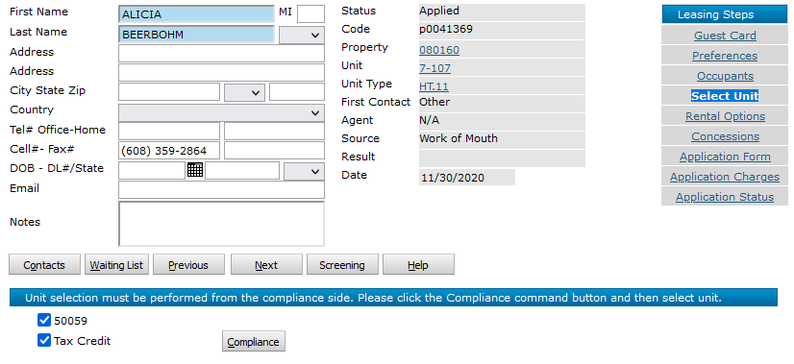

1. Then click **“Compliance”** button (make sure both boxes are checked as shown below)

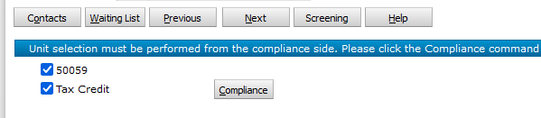

1. Then after clicking **“Compliance”** button you will goto the member details area 🡪 click on “Select Unit” option *(shown below)*
2. Then you want to make sure these dates are not old past dates (update to a later date 11/1 or something)



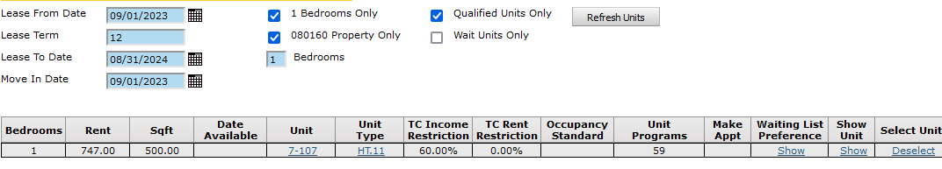

* Its possible the unit you want to assign to an applicant will not populate as “not available” if the date its checked available isnt until a later date then listed (as shown above intially for 9/1)
* If you search and find the unit number (Yardi) then 🡪 click on that unit number (shown below)

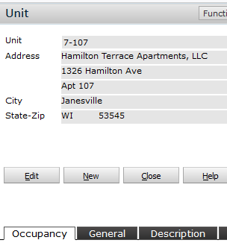

* Next Page
* Then from in the **Unit settings** options (shown below)🡪 Click the “**edit**” Button *(shown above)*
  + Then on the 1st “occupancy tab 🡪 just check that rent ready box (and update the date ready if need be)
  + Since *for instance,* this particular unit (shown on screenshot below) shows that the “Rent ready” box was already checked – But it is showimg that it is not rent ready until 10/10/2023

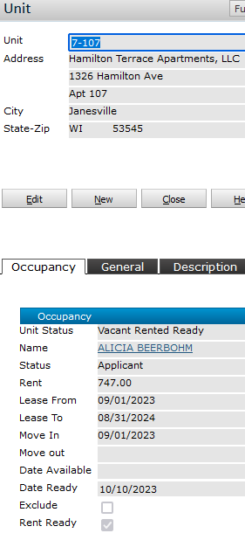

**THEN BACK TO UPDATING THE DATES IN THE COMPLIANCE AREA:**

* Find the applicant you want to assing the unit to again as you did before (instructed above)
* Once you update the dates (as shown below I updated to 11/1 for the lease from date)
  + Then to view **all** units **NOT** just the 1 bedroom 🡪 Just **Unselect the 1 bedroom check box**
  + I always usually **unselect the “qualified units**” check box too just to find out if maybe the unit I want to assign still shows up in the list (but just maybe isnt qualified)
* Then click on the **“Refresh units”** button (as shown below) The updated list of available units to be assigned will re-populated (for any units showing as available on or after the lease frome date entererd in the unit details –

*(as instructed above)*

* Then the unit you want to assign should show up in refreshed list *(even if its unavailble/unqualified to assign)*



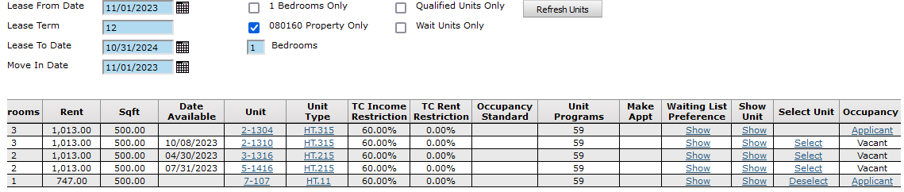

* If the “**Select**” button is not available under the “**Select unit**” column (as shown above) that means someone else is probably already assigned to that unit
  + So to see who is assigned click on that “**Applicant**” button under the “**occupanc**y” column
  + This will pull up the info of the applicant already assigned.
  + *(if they need to be canceled – go ahead and cancel them, then when you come back to refresh the unit list again youll see the “assign” button wil then show up)*
* One you find the unit you want to assign 🡪 Click the “**Select**” button for that unit
  + Then click the “**Next”** button to goto the next step and that’ll assign them  *(should then be assigned)*
* Next Page

**SIDE NOTE: If applicant is currently already assigned to a unit – under the “Select Unit” column, youll notice it’ll have a “Seselect” button next to the current assigned unit 🡪 it will not allow you to de-select it will make you select new unit available from the list or cancel the app (if they cancel that is) that’s the only way to “unassign” a unit really.**

**SIDE NOTE: Sometimes to see the correct unit populate in site manager after assignin a unit in Yardi, you need to open the app save it and then refresh the search screen in site manager to re-populated the updated unit (for whatever reason)**